DeFabio Spine and Sports Rehab, LLC
Chiropractic Acupuncture Nutrition
308 Springfield Avenue Berkeley Heights, NJ 07922 • 908-771-0220 • 908-771-0114

CONFIDENTIAL PATIENT INFORMATION
Patient Information |  |  |  |  |  | Today’s Date _______________________
Patient Name ________________________________________ |  |  |  |  |  | Date of Birth ____________________
Street Address _____________________________________________________________________________
City ______________________________________ |  |  |  |  | State _____________ |  |  |  | Zip ___________
Home Phone (____) ___________ |  | Work Phone (____) _____________ |  |  |  |  |  | Cell Phone (____) ____________
E-mail _______________________________________ |  |  |  | Preferred Language ____________________
Marital Status: S M W D |  |  | Ethnicity ___Hispanic/Latino ___Non-Hispanic/Latino
Race ___________________ | Gender ____M ____F |  |  |  |  | ____Left Handed ____Right Handed
Smoking status __Never __Former __Current __How much? ________ |  |  |  |  |  |  | SS# _____________________
Referred By _______________________________ Primary MD _________________________________
Employer/School _________________________________ Occupation _______________________________
Employer/School Address ____________________________________________________________________
Emergency Contact ________________________________ Emergency Contact Phone Number ___-___-____
Reason For Today’s Visit
List present complaints and injuries ___________________________________________________________
_________________________________________________________________________________________
How long have you had this condition? ______________ Does it bother you occasionally/frequently/constantly?
Who else have you seen for this condition? ______________________________________________________
What did they recommend? __________________________________________________________________
Pain Scale
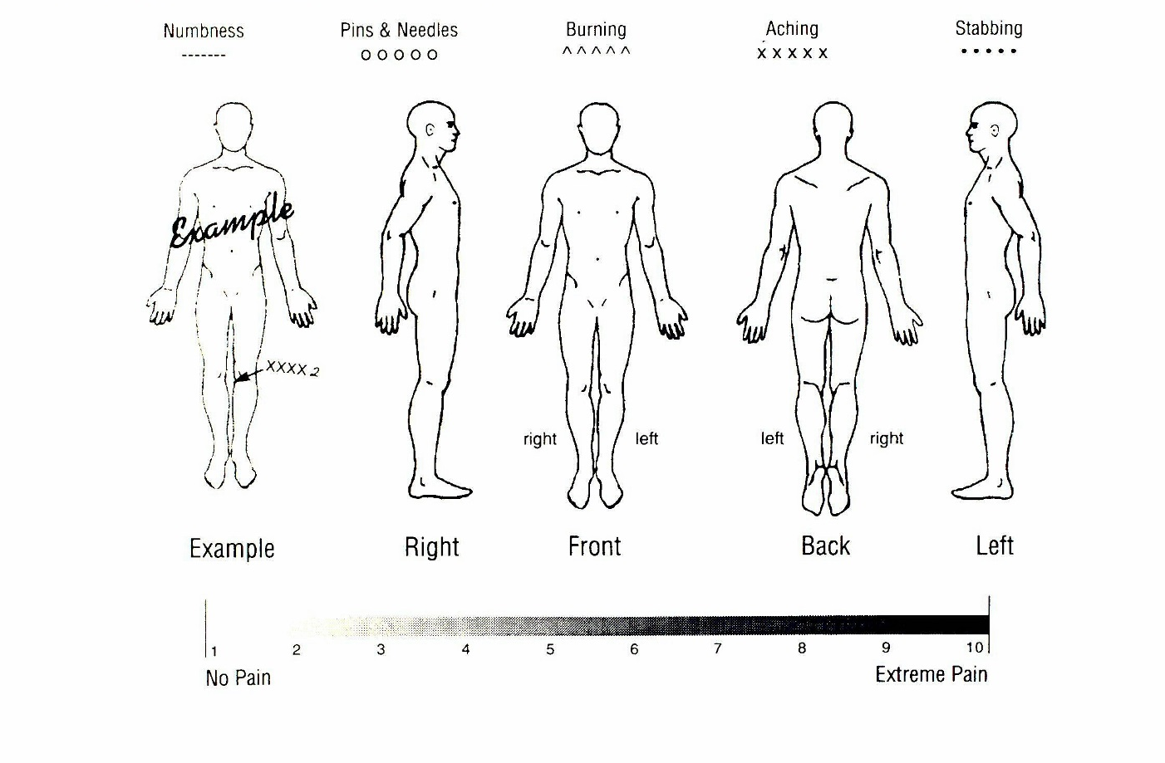

Patient Signature for Consent to evaluate and treat today: ___________________________________

DeFabio Spine and Sports Rehab, LLC

2020 Insurance Information and Assignment Authorization

Patient’s Name _______________________________ Date ______________________

Patient’s Social Security # ___/___/___ Insurance Company ______________________
InsuInsurance Policy # ____________________________ | Group # ___________________

Assignment Authorization and Agreement

I agree to provide the office with any information, initial or follow up referral forms prior to seeing the Doctor that are necessary for treatment or payment and

1. I hereby assign to this office my rights to receive payments from negligent parties or from insurance

companies. Payments should be payable and mailed to:

DeFabio Spine & Sports Rehab, LLC

308 Springfield Avenue

Berkeley Heights, NJ 07922

2. I understand this if this office receives more than their fees, the office will pay any credit balances to me, the patient.

3. I authorize the office to release any information to any insurance company, adjustor or attorney that will assist in the payment of a claim.

4. I fully understand and agree that insurance policies are an arrangement between an insurance carrier and myself. I will be responsible for any expenses not paid by insurance.

5. A photo copy of this form shall be as valid as the original.

_____________________________________ __________________
Patient’s Signature Date

Patient’s Notice of Privacy Practices

I, __________________________________________, acknowledge I was offered a copy of DeFabio Spine & Sports Rehab’s Notice of Privacy Practices, with complete understanding and I had all my questions answered to my satisfaction.

I am authorizing DeFabio Spine & Sports Rehab, LLC to have my name displayed in the office in the form of a ‘sign-in sheet’ and a ‘patient referral sign’.

Yes No

I may be contacted in the following manner:
E-mail address__________________________ via defabiochiropractic@gmail.com, a non-encrypted server
Best telephone number to contact me ___________________
OK to leave a detailed message Leave a message with a call back number only
I authorize ___________________________access to release my health records
Relationship to patient: ____________________

_____________________________________ __________________
Patient’s Signature Date

DeFabio Spine and Sports Rehab, LLC
Chiropractic Acupuncture Nutrition
308 Springfield Avenue Berkeley Heights, NJ 07922 • 908-771-0220 • 908-771-0114

Payment Policy

To pay your balance once your insurance company has processed your visit, a current credit card needs to be on file with authorization of payment. Once the insurance claim is processed your credit card will be charged the balance and an itemized receipt will be mailed to you.

Payment Authorization

I hereby authorize DeFabio Chiropractic Associates to automatically charge my credit card for:
1 The allowable balance due after my insurance payments are made.
- For insurance payments sent directly to me.
- For my co-payment when due.
- For non-covered services.
- Missed appointment fee.

A copy of the itemized statement and credit card receipt will be provided for your records.
Would you like a copy of your receipts?
□Yes □No

Name_________________________________________ Date______________

Signature_______________________________________ Zip code _________

MC Visa #____________________________________ Expiration Date____
CVS___

Am Ex #____________________________________ Expiration Date____
CVS___

All information is confidential and secure.

